The 7th Goldreed Industrial Design Award global call for entries was officially launched!
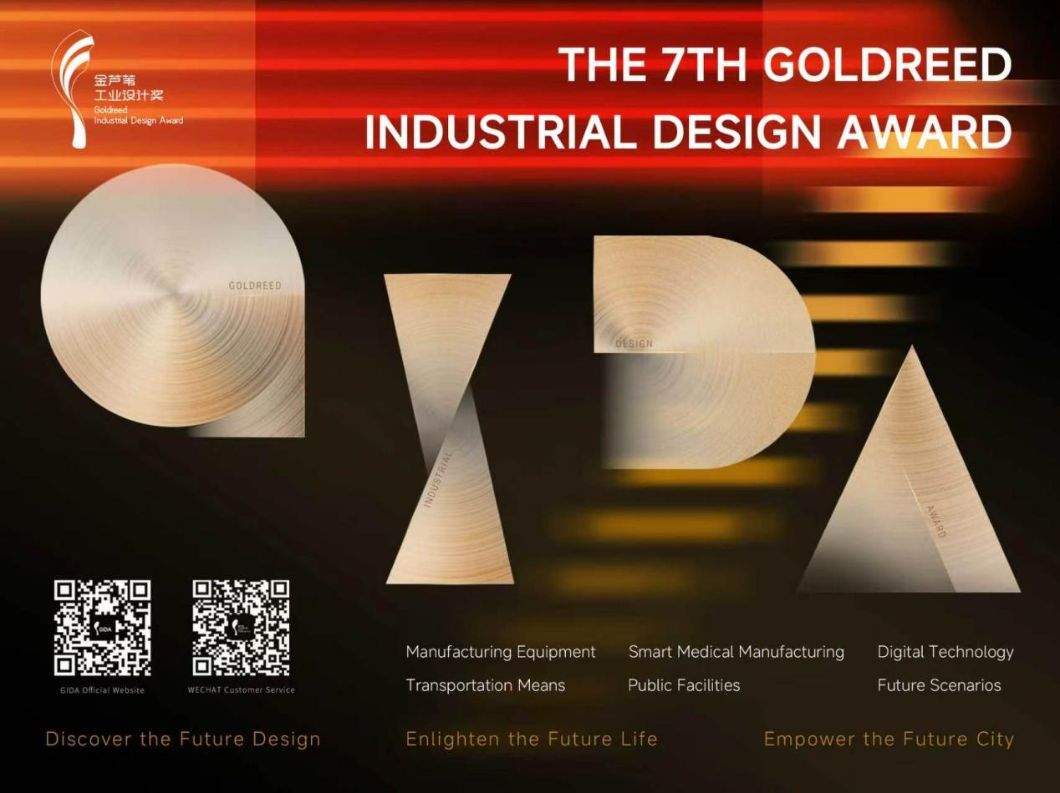
XIONGAN,China,July 1,2026–The 7th Goldreed Industrial Design Award(GIDA)today announced the official launch of its global call for entries,inviting the world’s most innovative designers and enterprises to participate.
The call for entries will be open from July 1,2026 to 24:00(Beijing time)on July 20,2026. Enterprises and institutions, design agencies, colleges, design teams, scientific research institutions and individuals from any country and region in the world can log on to the official website of GIDA(www.goldreedaward.com/en) to register for free.
Rooted in Xiongan, China--the world’s future city–GIDA aims to gather premier global design resources and bring them to life in Xiongan. Participating in GIDA offers a unique opportunity to connect with Chinese manufacturers seeking global innovation for industrial upgrading,collaborate with the Chinese government on building the city of the future,and leverage GIDA’s extensive media network to access the Chinese market.
Since its launch in 2019, GIDA has received over 42,000 entries from 91 countries and regions, with a total of more than 27 million RMB awarded to outstanding designs. The influence and popularity of the awards have been increasing globally.

Which works can be registered?(6 Categories)
Manufacturing Equipment
Focus on intelligent manufacturing,green construction,and smart operation.Includes underground utility inspection robots,prefabricated building equipment,distributed energy facilities,and smart agricultural equipment supporting the Xiongan modern industrial system.
Smart Medical Manufacturing
Focuses on designs promoting human physical and mental health.Includes high-end medical devices,therapeutic products,pharmaceutical production equipment,medical rehabilitation equipment,nursing care products,and health management systems.
Digital Technology
Focuses on innovative design applications of AI,blockchain,digital tech,and information services.Includes industrial software,public services,smart city systems,blockchain applications,digital twin platforms,and AI service terminals.
Transportation Means
Smart transportation designs,including unmanned vehicles,smart buses,high-speed trains,automobiles,aircraft,mobility tools and facilities,service-oriented vehicles,water/underwater vehicles,and traffic robots.
Public Facilities
Product designs for urban service facilities,including urban furniture,public lighting,guiding signs,shared facilities,information services,sanitation and safety facilities,leisure/entertainment amenities,and emergency equipment.
Future Scenarios
Focuses on future life,culture,and technology integrated with creative thinking and innovative scenarios.Includes future living home,child-friendly and ageing-friendly products,cultural creativity,fashionable apparel,packaging design,IP image,and digital culture.

What’s New in the 7th Edition?
The 7th GIDA is divided into two main competition groups:
Product Group:For products launched within three years(after May 2023)or ready for market before the award ceremony in September 2026.Physical products or functional prototypes are required for the second evaluation.
Concept Group:For original,market-ready designs that are highly innovative in function,structure,materials,and low-carbon concepts.Prototypes or models are required for the second evaluation.

What awards can I win?
The 7th Goldreed Industrial Design Award offers a total cash prize of 4.5 million RMB.Key awards include:
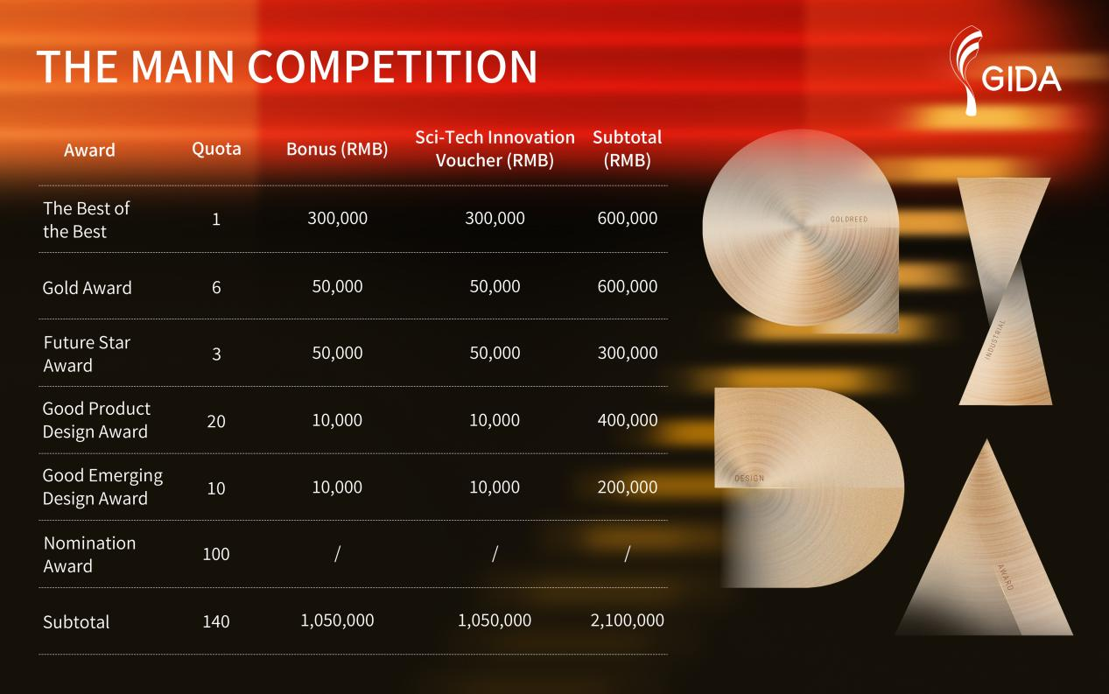
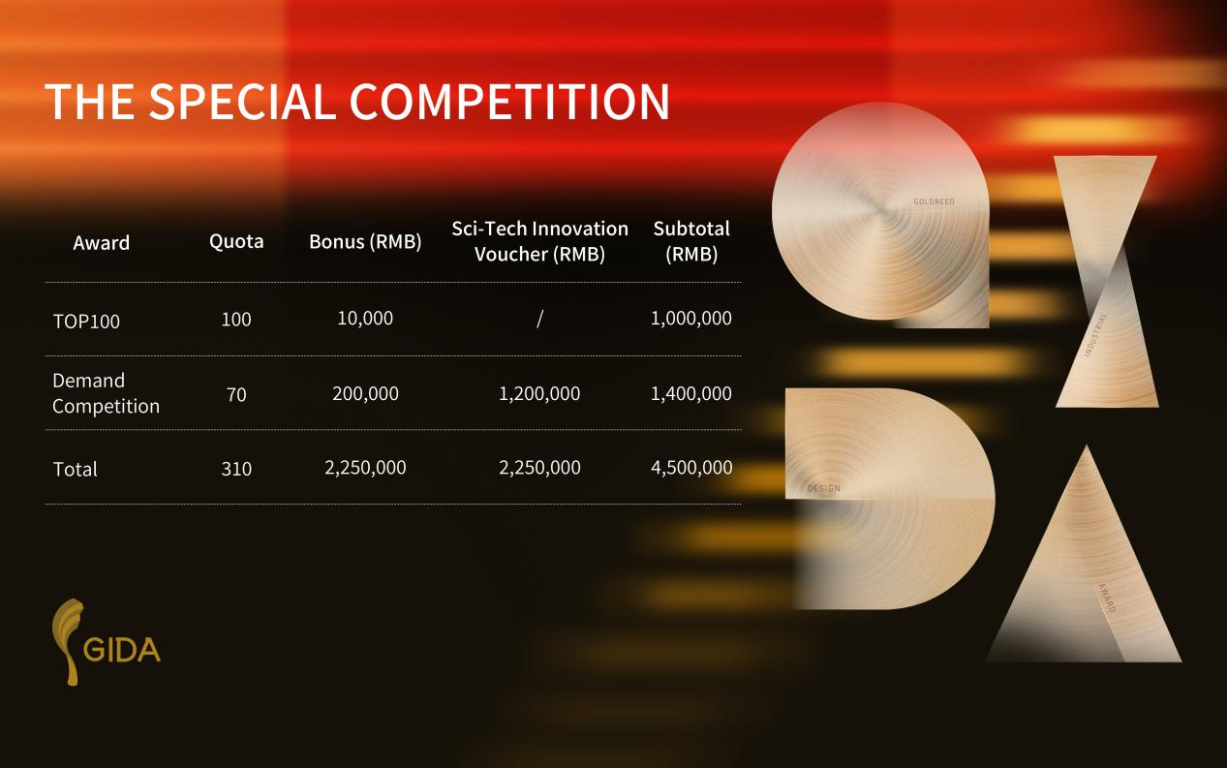Note:The Sci-Tech Innovation Voucher is issued according to relevant Xiongan New Area policies to support winning enterprises.

Why Participate?Key Benefits for Winners
Trophy&Certificate:Lifetime recognition and an electronic award certificate.
Logo Usage:Lifetime free use of the“GIDA”winner’s logo.
Industrialization Support:Connect with investment,incubation,and crowdfunding institutions to promote project industrialization in Xiongan.
Expert Exchange:Invitation to the award ceremony and Hebei International Industrial Design Week for networking with global design leaders.
Media Promotion:Exposure through GIDA’s global media network of over 200 outlets.
Yearbook Inclusion:Your work featured in the official GIDA yearbook.
Government Funding&Talent Support:Access to financial incentives,talent introduction programs,the“Xiongcai Card”(offering various service guarantees),and preferential policies for enterprise listing and financing in Xiongan New Area.
Xiongan Trip:An exclusive tour of Xiongan’s key industrial parks and AI and new materials benchmark projects,with face-to-face government exchange(travel expenses borne by entrants).

Schedule
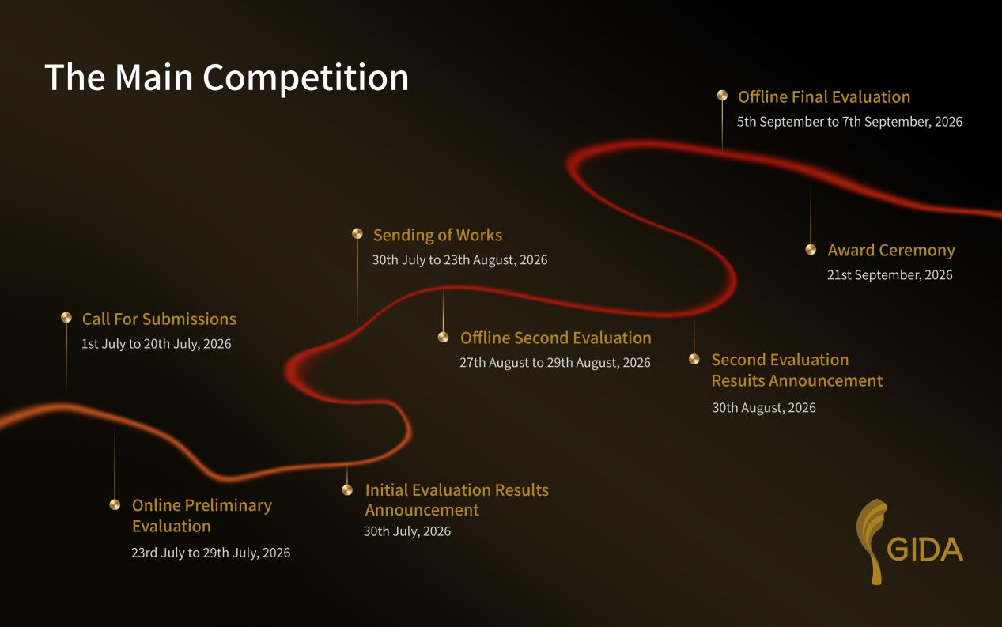
Contact:
Goldreed Industrial Design Award Organizing Committee
Website:www.goldreedaward.com/en

Ruby Zhang
service@xidi.org.cn

